**DAILY ONLINE ACTIVITIES SUMMARY**

|  |  |  |  |  |  |  |  |  |
| --- | --- | --- | --- | --- | --- | --- | --- | --- |
| **Date:** | **19/05/2020** | | | | | **Name:** | **RITIKA KULKARNI** | |
| **Sem& Sec** | **4thSEM. & ‘B’ SEC.** | | | | | **USN:** | **4AL19CS403** | |
| **Online Test Summary** | | | | | | | | |
| **Subject** | | **DESIGN ANALYSIS OF ALGORITHMS** | | | | | | |
| **Max. Marks** | | **30** | | **Score** | | | **10** | |
| **Certification Course Summary** | | | | | | | | |
| **Course** | **Python for Machine Learning** | | | | | | | |
| **Certificate Provider** | | | **Greatlearning**  **Academy** | | **Duration** | | | **5 Hrs.** |
| **Coding Challenges** | | | | | | | | |
| **Problem Statement:A user will input two strings, and we find if one of the strings is a sub**  **sequence of the other. Program prints “yes” if either the first string is a sub sequence of the second string or the second string is a sub sequence of the first string. Assume that, the length of the first string is smaller than or equal to the length of the second string.** | | | | | | | | |
| **Status:** | | | | | | | | |
| **Uploaded the report in Github** | | | | | **Yes** | | | |
| **If yes Repository name** | | | | | <https://github.com/ritikakulkarni/QuarantineCoding> | | | |
| **Uploaded the report in slack** | | | | | **Yes** | | | |

**Online Test Summary: 18CS42 test was scheduled from 9:15 am to 9:55 am.The portion for the IA was 4 th module there were 25 questions and the time assigned was 40 minutes the questions were mcq type. But there was an issue with the time mentioned, so that we got only 30mins. to finish the test. The time was not sufficient to answer all the questions. There were 20 questions of 1 marks and 5 questions of 2 marks respectively.**

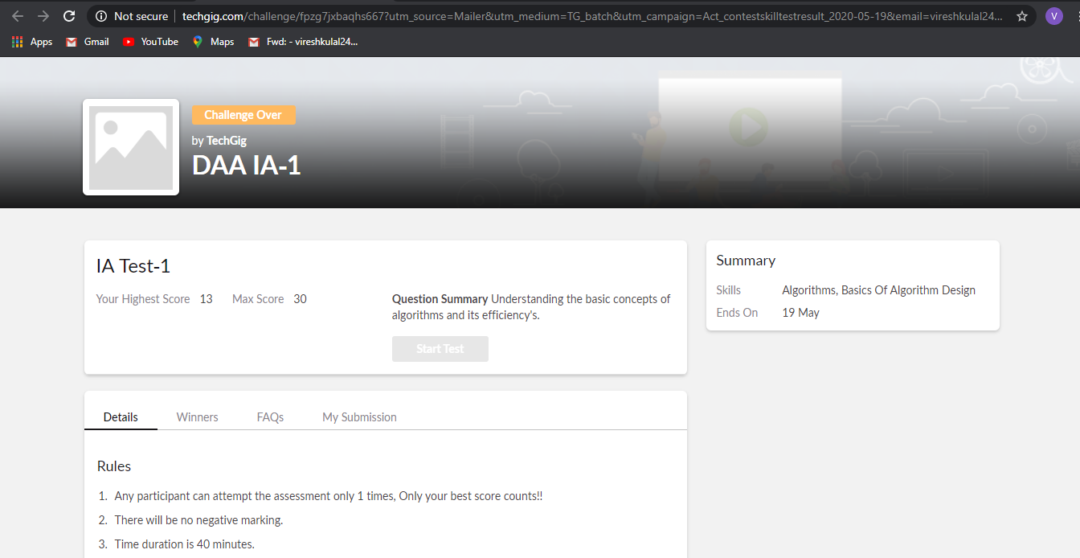

**Online Certification Course Summary: Today I have learnt about the jupyter notebooks ,how to create a new note book and how to execute the code in the cell provided in the notebook and about some of the keyboard shortcuts which helps to execute the code and to achieve the output and some of the basic data structure hands-on.**

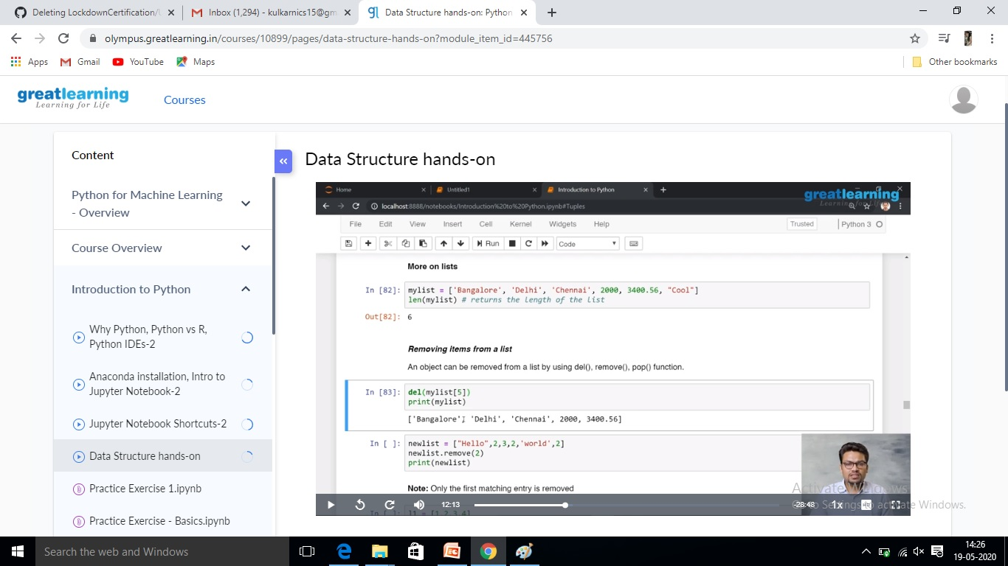

**Online Coding Summary:Online Coding Summary​: Online coding Summary: Today I received one program from Prof.Venkatesh CSE Dept. The program is mentioned above(pg.01). to my GitHub repository and I’ve shared the snapshot below.**

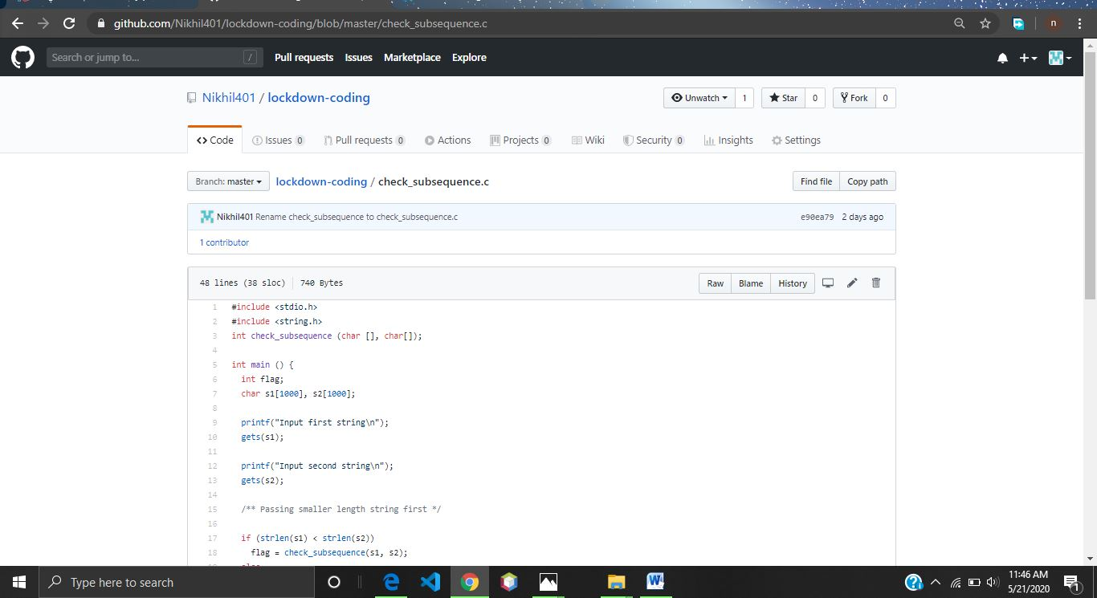

**Thank you.**